Good afternoon,
Below you will find instructions for completing our fourth Checkpoints of the semester. We will be using these checkpoints as a first grade team to help meet all the needs of our students.
In addition, we will be starting a Checkpoint Day. We will use our class time on Thursday, December 4th to complete them in breakout rooms. This will take place of our regular scheduled math and reading group ClassConnects. If you are interested, please join us! Students can choose to complete the Checkpoint in the ClassConnects on Thursday or continue to reply to the kmail.
Directions- Please read the following questions to your student. Reply to record their work in the spaces provided in this kmail. (You must click “reply” before it will let you type in the boxes.) It is okay if |student.firstname| does not know the correct answers. In order to provide instruction based on our student’s needs, the questions need to be completed without assistance.

Name: |student.firstname|

Due: December 5th
Grade 1: Math Checkpoint Assignment #4

Objectives:
Add and subtract within 20, demonstrating fluency for addition and subtraction within 10. Use strategies such as counting on; making ten (e.g., 8 + 6 = 8 + 2 + 4 = 10 + 4 = 14); decomposing a number leading to a ten (e.g., 13 - 4 = 13 - 3 - 1 = 10 - 1 = 9); using the relationship between addition and subtraction (e.g., knowing that 8 + 4 = 12, one knows 12 - 8 = 4); and creating equivalent but easier or known sums (e.g., adding 6 + 7 by creating the known equivalent 6 + 6 + 1 = 12 + 1 = 13).

Task 1: Use a strategy you have learned, or math facts, to solve for the missing addend.
____ + 4 = 19

Task 2: Explain how you solved the problem ___ + 4 = 19. (Learning Coach: Write the student’s dictated response.)

Task 3: Explain. What does it mean to subtract 6 cars from a 13 cars? (Learning Coach: Write the student’s dictated response.)

Task 4: Complete with the missing symbol.
15 + 2 ___17 | A.
3 = 12 ___9 | B.
6 - 2 ___ 7 - 3 | C.

Grade 1: ELA Checkpoint Assignment #4
Objectives:
CCSS.ELA-Literacy.RL.1.3
Describe characters, settings, and major events in a story, using key details.
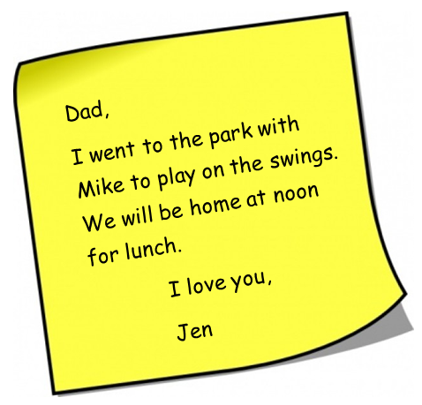

Directions: Using details from the note, answer the questions below. Learning Coach, please type what student says.

Task 1: Write a sentence that tells who is with Jen.

Task 2: Write a sentence that tells where they are.

Task 3: Write a sentence that tells why they went to the park.

Task 4: Write a sentence that tells when they will be home.

