Good morning,

Below you will find instructions for completing our third ELA checkpoint of the semester; however, this is the first checkpoint that includes a writing element.

Directions- Read the following story and answer the question. (You must click “reply” before it will let you type in the boxes) If the student is struggling, learning coaches can assist with reading the passage.

Use the following steps when answering the question.

1. Read the questions carefully.

2. Highlight key words in the question.

3. Restate the question and answer the question completely.

Name: |student.firstname|

Due: November 7th, 2014

Grade 1: ELA Checkpoint Assignment #3

**Objectives:**

[CCSS.ELA-Literacy.W.1.8](http://www.corestandards.org/ELA-Literacy/W/1/8/)  
With guidance and support from adults, recall information from experiences or gather information from provided sources to answer a question.

[CCSS.ELA-Literacy.W.1.5](http://www.corestandards.org/ELA-Literacy/W/1/5/)  
With guidance and support from adults, focus on a topic, respond to questions and suggestions from peers, and add details to strengthen writing as needed.

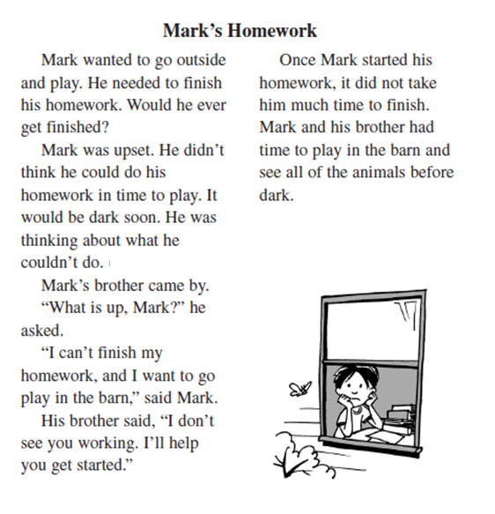

|  |
| --- |
| **Question: How is Mark feeling? Use details from the story to tell why.** |
|  |